Hello Yakin,

I want to start working on the Status Bar for Manna

I would like to have a Status Bar similar to the one you have on Business Lab or one that Domino’s Pizza uses .There Tracker tracks the orders / pizza showing you each stage of prep to your door

Purpose: The purpose of the status bar is to keep the case manager aware of the different phases of the acceptance process without having to make multiple calls to update on the status of acceptance.

1. This lessees the work load of both our members and the case managers
2. Case manager can check status of their request and members can stay in communication without being hounded by multiple phone calls
3. Speeds up and simplifies the discharge process

The 5 box bar will indicated the status of the task being worked on or completed at these five points of calls that require follow up. They will be as follow:

Box

#1. Clinicals received- (eliminates the multiple calls if clinicals are in the hands of the right person)

#2. Clinicals in review – (eliminates the call asking if clinicals are being reviewed yet)

#3. Pending insurance – (means that the Member has excepted the patient as long as insurance approved; also the clinical have been passed on to the insurance company )

#4. The patient has been approved or denied

#5. MOT completed – (this means that the process is complete and the patient is all set to receive our member’s services)

Things to consider:

1. The website must be able to accommodate several status bar per case manager (ie each Case manager could have several patients waiting for placement at a time)
2. I am thinking the bar should be linked to the Lead forms and that we could give a choice if they want to track the status or not
3. Each status bar must have an identification code attached to it because I don’t want to use patient’s names only a 4 digit number
4. I must customize the automatic Lead email that is sent out to both member (that will be given the lead) and case manager, To reflect the status bar option the lead) and case manager, To reflect the status bar option
5. 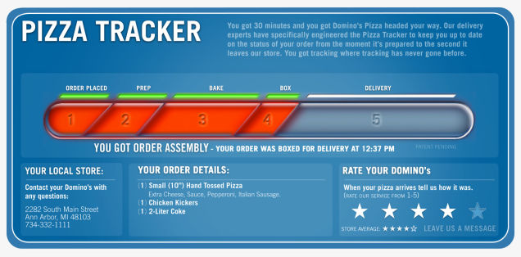

|  |  |  |  |  |
| --- | --- | --- | --- | --- |
| Clinicals  received | Reviewing Clinicals | Pending insurance approval | Approval  Or  Denial | MOT complete |
| Comments |  |  |  |  |
|  |  |  |  |  |